REPORT TEMPLATE FOR MECHATRONICS DESIGN APPLICATIONS – II (MTU-II) (MARCH – 2023)

(Student name should go here) (Student number should be written here)

(The above line can be duplicated for project work accomplished as a team)

Erciyes University, Faculty of Engineering, Department of Mechatronics Engineering - KAYSERİ

This template was designed to help you create professional-looking reports for Mechatronics Design Applications - II (MTU-II) as well as graduation projects. Explanatory notes have been given in several places marked in yellow. You can delete these notes as you are preparing your reports and replace them with your own text.

This is the abstract section of your report. The abstract should summarize the basic topic of your work and the results obtained and should be a single paragraph. It should not exceed 200 words. At the end of the abstract, a single blank line should be left and keywords for information retrieval purposes (no more than five) should be given.

Keywords: National symposium, circuit theory and applications

1. INTRODUCTION
As of the beginning of the 2022-2023 Spring semester, all reports for submission to Mechatronics Design Applications - II (MTU-II) should be prepared using this template. You can download this template as a Microsoft Word template from the department web site (https://mekatronik.erciyes.edu.tr) and replace the text with your own.

2. COVER PAGE
The title should be written fully capitalized (13 point bold type). The title should reflect the contents of the report and should be concise and self-explanatory. Below the title, names student numbers and email addresses of all students who took part in the project should be written.

2.1. Abstract

The abstract should be written as outlined above. Please do not forget the keywords.

3. TEXT
This is the main body of your report, which should talk about the theoretical and experimental work that forms the essence of your project. Please make sure to stick to the technical terms in common usage for the topic of your project. The titles of the specific sections (and subsections if necessary) can be adapted for your specific topic.

4. SYMBOLS AND ABBREVIATIONS
Any symbols and abbreviations not clarified in the text should be listed here.

Symbol Explanation
ℒ Laplacian operator
µ Friction coefficient

Abbreviation Explanation
FFT Fast Fourier Transform
CAN Controller Area Network

5. EQUATIONS
All equations used as part of the report should be written using an equation editor (Equation Editor in Microsoft Word, MathType or the like). All equations should be numbered as shown in the examples below.

$α_{pq}=\sum_{r=1}^{N}{\frac{φ_{pr}φ_{qr}}{ω_{r}^{2}-ω^{2}+jη_{r}ω_{r}}}$ (1)

$\frac{∂^{4}y\left(x,t\right)}{∂x^{4}}+\frac{m}{EI}\frac{∂^{2}y\left(x,t\right)}{∂t^{2}}=0$ (2)

All symbols and expressions should be explained where they are first referenced in the text.

6. ENVIRONMENTAL IMPACT ANALYSIS

IMPORTANT NOTE: This section is a compulsory section of your report and the table shown below MUST be included. The main objective of this table is to increase your awareness regarding any possible impact of your work on the environment. As you may well know, impact on the environment is an increasingly critical aspect of the development of any and all products and in general engineering solutions to societal problems. As such, please fill out this table considering all possible environmental impact of your work in general.
Table 3.2. Environmental impact and sustainability analysis.

The project does not include activities concerning environmental sustainability ☐
The project includes activities concerning environmental sustainability ☐

If your project includes activities on environmental sustainability, please fill out the relevant sections in the table below.

 | (YES) | (NO) | EXPLANATION  (If you answered YES to the question, please provide a brief explanation)
Does the project include any activities regarding applications of renewable energy sources?
Does the project include activities on environmental sustainability?
Does the project include activities on agricultural sustainability?
Does the project include activities on recycling?
Does the project concern sensing and/or control of greenhouse gas emissions or other environmentally harmful gases?
Does the project concern sensing and/or control of agriculturally or environmentally useful gases?
Does the project concern reductions in energy usage?

7. COST ANALYSIS
(The cost analysis table included in this section is one of the most important sections of your report. One of the most important skills you need to acquire for your career is the ability to critically evaluate the cost of projects you may be involved in. You will also most likely be called upon to optimize the cost structure of your project by finding alternative methods of solving technical problems. An important part of this is to research and document the cost of every item used to realize your project (including, but not limited to, any tools, machinery, materials, software licenses etc.).

Table X –Project Cost Analysis
Cost Item | Cost (TL)
Item 1
Item 2
TOTAL

7. REFERENCES

The ‘References’ section is at the end of your report and is one of the most important sections. It is very important to list any and all sources used while preparing your report. Failure to do this is interpreted as passing off somebody else’s work as your own and is commonly known as ‘plagiarism’. Plagiarism is a serious ethical violation in the academic community, with severe consequences. All references should be numbered in the order in which they were first referenced in the text, and should be referred using square brackets, as in [1], [2], [3,4] ve [4-7] etc. Formatting of different types of references should be as shown below.

6.1. Formatting of References According to Type
References should be formatted according to their type as shown below.

If the reference is a journal article:

Author 1 last name, First letter of Author 1 first name, Author 2 last name, First Letter of Author 2 first name. (Year) Title of Article, Journal Name, first page number – last page number, DOI (Digital Object Identifier) if available.

EXAMPLE:
[1] Hüseyinoğlu, M., Çakar, O. (2017). Determination of stiffness modifications to keep certain natural frequencies of a system unchanged after mass modifications, Archive of Applied Mechanics, 87(10), 1629-1640. DOI 10.1007/s00419-017-1276-3.

If the reference is a book:

Author last name, First letter of author first name (Year). name of the book, Publisher name, Name of the city where published.

EXAMPLE:

[2] Söylemez, E. (2013). Makina Teorisi 1-Mekanizma Tekniği, Birsen Yayınevi, İstanbul.

If the reference is a published thesis:

Author last name, First letter of first name. (Year). Title of the thesis, type (master’s thesis, doctoral dissertation), University, Name of institute/graduate school.

EXAMPLE:

[3] Hüseyinoğlu, M. (2017). Yapısal dinamik analiz için sonlu elemanlar modellerinin frekans tepki fonksiyonları kullanılarak doğrulanması ve güncellenmesi, Doctoral Dissertation, Fırat University, Graduate School of Applied Science.

If the reference is a paper published as part of the proceedings of a conference or symposium:

Author last name, First letter of first name. (Year). Paper title, Name of the conference or symposium, organizer, city where the symposium or conference took place.

EXAMPLE:

[4] Hüseyinoğlu, M., Çakar, O. (2015). Bir kütle-yay sisteminde belirli bir doğal frekansı değiştirmeksizin ters yapısal değişiklik yapılması, Uluslararası Katılımlı 17. Makina Teorisi Sempozyumu, İzmir Yüksek Teknoloji Enstitüsü, İzmir.

If the reference is a web site:

Web site URL, Date last accessed.

Important note: As the content of web sites could change over time and may be inaccessible for a variety of reasons, you are strongly recommended NOT TO USE web sites as references.

EXAMPLE:

[5]http://guides.library.uwa.edu.au/mendeley/citation_styles, Last accessed: September 12, 2019.

Tablo 1. An example table.

Sempozyum adı | Yer | Yıl
15. Ulusal Makina Teorisi Sempozyumu | Niğde | 2011
16. Ulusal Makina Teorisi Sempozyumu | Erzurum | 2013
Uluslararası Katılımlı 17. Makina Teorisi Sempozyumu | İzmir | 2015
18. Ulusal Makina Teorisi Sempozyumu | Trabzon | 2017
19. Ulusal Makina Teorisi Sempozyumu | İskenderun | 2019
20. Ulusal Makina Teorisi Sempozyumu | Diyarbakır | 2021

7. TABLES AND FIGURES

Any visual data that does not include tables (photographs, drawings, diagrams, graphs, maps etc.) should be referred to as a ‘Figure’. All tables and figures should be numbered consecutively in the order in which they are first referenced in the text, and should be placed as closely as possible to the place where they are first referenced. Table headings should be placed at the top of the table, and figure captions should be placed directly underneath the figure. Table headings should be left justified, and figure captions should be centered with 9 pt font. Any text in the tables should never be smaller than 8 pt font. It is preferred that a table be placed entirely in one page; however, in extreme circumstances, a table can spill over into the adjacent page. Figures should never include handwriting. All graphs and photographs should be in printable quality. Color photographs may be accepted but any printouts will most likely be black-and-white. Columns can be combined if deemed necessary (see Figure 1).

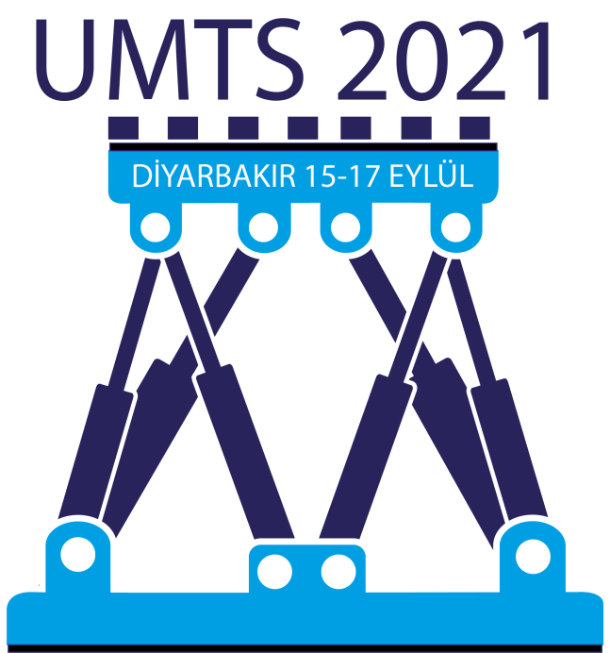

Şekil 1. UMTS 2021 logo.

8. FOOTNOTES

Footnotes should be avoided to the extent possible. However, if really necessary, they can be included in the page referenced with a line to separate it from the main text.

